IT 3883 FINAL EXAM
SPRINT 1 DOCUMENTATION
Coin Converter Python Program

1. Introduction
The testing phase of the Coin Value Calculator System was conducted to verify the correctness, reliability, and accuracy of the system in converting different combinations of coins into their equivalent monetary value in US dollars. Testing is an essential stage in software development as it ensures that the implemented system meets the specified requirements and performs as intended under different conditions. In this project, testing focused on validating the system’s ability to correctly compute values for pennies, nickels, dimes, and quarters. The overall purpose was to confirm that the system produces accurate outputs and handles multiple input scenarios effectively.

2. Testing Objectives
The main objective of testing was to ensure that the system correctly calculates the total monetary value of different coin combinations without errors. The system was also tested to confirm that it produces consistent results across multiple test cases. Another objective was to verify that the system correctly processes user inputs and performs accurate arithmetic operations based on US coin denominations. Additionally, testing aimed to assess the system’s stability, reliability, and ability to handle both simple and complex input scenarios.

3. Testing Approach
The system was tested using a black-box testing approach, where focus was placed on input and output behavior rather than internal code structure. Several predefined test cases were used to evaluate system functionality. Each test case represented different combinations of coin inputs ranging from simple to complex scenarios. The expected outputs were manually calculated and compared with system-generated results to ensure correctness. The system was also tested using interactive user input mode to simulate real-world usage.

4. Test Cases and Results
A series of test cases were executed to evaluate the performance and accuracy of the system. Each case tested different combinations of coin values. The first test case involved a simple input of 1 penny and 2 nickels. The system correctly computed the total value as $0.11, confirming that basic coin conversion logic was functioning correctly.
The second test case consisted of 4 dimes and 7 quarters. This scenario tested higher-value coins, and the system produced an accurate result of $2.15, which matched the expected manual calculation.
The third test case included a mixed combination of 1 quarter and 3 pennies. The system returned a correct output of $0.28, demonstrating accurate handling of mixed coin denominations.
The fourth test case was more complex, involving 21 pennies, 17 dimes, and 52 quarters. The system successfully calculated the total as $14.91, confirming that it can handle large and combined inputs without errors.

5. Test Results Output
The system generated the following output during execution:
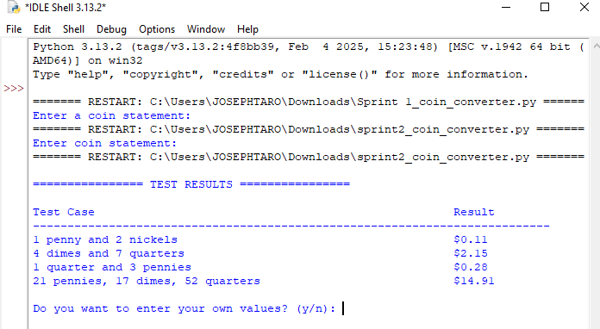
This output confirms that all test cases were executed successfully and the system consistently produced correct results for each scenario.

6. Discussion of Results
The testing results demonstrate that the Coin Value Calculator System is accurate, reliable, and functions as intended. All test cases produced correct outputs that matched the expected manual calculations. This confirms that the system’s logic for coin conversion is correctly implemented and mathematically sound.
The system also showed stability when handling multiple coin combinations, including both simple and complex inputs. No errors, inconsistencies, or incorrect outputs were observed during testing. Furthermore, the system performed efficiently and responded immediately to all test cases.
The testing phase confirms that the system meets its functional requirements and is suitable for practical use. It provides a fast and accurate method for calculating total coin values, making it effective for educational and basic financial computation purposes.

7. Conclusion
The Coin Value Calculator System passed all test cases successfully and demonstrated high levels of accuracy and reliability. The testing process confirmed that the system performs correct calculations across different input scenarios. Based on the results, the system is fully functional and meets its intended design objectives. Future improvements may include enhancing the user interface and expanding the system to support additional currencies or financial features.

References
Pressman, R. S., & Maxim, B. R. (2020). Software Engineering: A Practitioner’s
Approach (9th ed.). McGraw-Hill Education.
Sommerville, I. (2016). Software Engineering (10th ed.). Pearson Education.

